Q) Write a short note on Kautilya’s Mandala Theory.

Ans: The Mandala theory was formulated by Kautilya in his work on politics,the Arthashastra.The Rajmandala or Raja-mandala meaning “circle of kings” ,mandala is a Sanskrit word that means “circle.” This theory describes circles of friendly and enemy states surrounding the king’s state. It is also known as Mandala theory of foreign policy . The mandala system was a theoretical construction of states by Kautilya. It is a geographical concept of division of lands of the king or the Vijigishu and the neighbouring kingdoms.Mandala theory is the plan,the blueprint of the expedition with the intention of world conquest because Kautilya believes in strength and power.The Mandala theory or the circle of the states consist of 12 kingdoms.

The fundamental objective of Kautilya was to make the state stronger,safer and expand as well. He considered territorial conquest as a necessary political function of every monarch. So , he was of the view that the potential conqueror king / the Vijigishu could fulfill his ambition of world conquest if he followed the mandala theory.The ultimate goal of the Vijigishu is the attainment of happiness and welfare of the kingdom and for this ,he must be prepared to do anything and everything.

Mandal theory(mandala means circle) -theory on geo-politics and balance of power and also he applies principles of psychology to geography and foreign policy. Principles are -

1) A king needs to acquire power.

2) Greater the distance, lesser is the enmity.

3) A neighbour is a natural enemy.

4) Enemy of an enemy is a friend.

The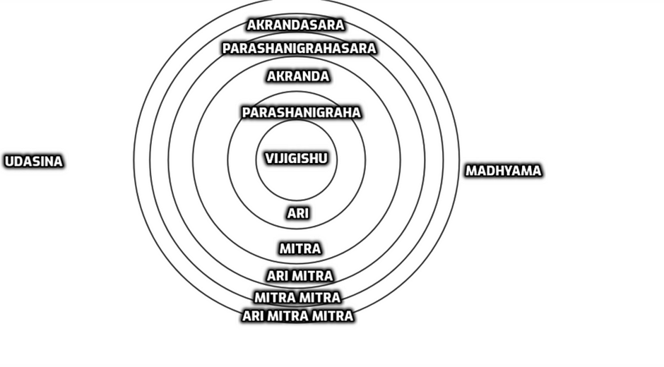

The Mandala theory of Kautilya

The Main Elements of Mandala Notion

1) Vijigishu ( Raja mandala):The potential conqueror or the central king. The conqueror who has two goals to have war and to conduct peace.Any and every other king in the mandals who have similar ambitions and the potential strength may be called a Vijigishu.The border of the kingdom of the Vijigishu is divided into two parts,the front and the rear.

2) Ari ( enemy state): The immediate neighbour in the front/north is the Ari, or the Enemy. Ari is the natural enemy in the front.

3) Mitra(ally): Mitra is the natural ally of the Vijigishu, whose territory is immediately beyond the enemy or ari.

4) Ari Mitra( enemy’s ally): Naturally the Ari Mitra is the ally of the Ari(enemy) and enemy of the Vijigishu.

5) Mitra-Mitra( ally of friend): The next state adjacent to Ari Mitra( his arch enemy)is Mitra-Mitra. He is naturally the Mitra’s friend and the Vijigishu’s ally as well.

6) Ari Mitra-Mitra: Next to Mitra is the state Ari Mitra -Mitra which means enemy of ally’s friend.

7) Parshnigraha(rearward enemy): The enemy, in the back/south of the Vijigishu.

8) Akranda( ally of Raja Mandala): Vijigishu’s ally in the rear behind that of Parshnigraha.

9) Parsnigrahasara( ally of a rearward enemy): Enemy’s ally,the ally of Parshnigraha behind Akranda.

10) Akrandsara( ally of Akranda): The ally of Akranda behind Parshnigrahasara, ultimately an ally.

11) Madhyama(middle king): The middle king with territory adjoining those of Vijigishu and Ari and stronger than both. It is important for the king and plays a strategic role.Ex from India’s perspective, Nepal.

12) Udasina(neutral): The kingdom lying outside or neutral and more powerful than that of Vijigishu,Ari and Madyama. Ex from India’s perspective, USA.

Mandala theory’s limitations -

1. In Kautilya’s time, land was the primary source of wealth and if a king wants to acquire more wealth, territorial expansion was the primary method. But today, the world is filled with nuclear powers & waging war for territorial expansion is not a smart move
2. Today, collective security and collective defence are relevant & an attack against one country will draw the others to take necessary action
3. Also, the world is globalized and due to low logistic costs for trading, neighbours are the biggest assets. Ex Though India and China are in a territorial conflict, the trade between them is nearly $90 billion, also India imports 70% of API(active pharmaceutical ingredients) from China and is highly dependent on China for its pharmaceutical industry(also smartphones domination)
4. Today, countries also need to consider their energy needs & security needs. And as there is a common threat of terrorism, countries have already joined hands to fight against it. There is no scope in Mandala theory for all these national interests.
5. Also, Kautilya wants the king to go on a conquest and conquer territories. There were incidences when a portion of this theory was relevant, such as Annexation of Kuwait by Iraq, Annexation of Crimea by Russia, Tibet occupation by China etc. But altogether, today, the world is more dynamic & also nations are joining hands to fight against terrorism, leaving little room for conducting expansionist policies against each other.

Thus the Mandala theory is the basis of Kautilya’s foreign policy.In other words, it is a theory of world conquest. He has paved the way for the Vijigishu to be a Chakravartin or world conqueror through his theory.