Marchantia
Marchantia is a genus of bryophytes. They are liverworts and found in moist and shady places. They lack true roots, stem and leaves. The plant body is thalloid.
Bryophytes are known as the amphibians of the plant kingdom as they require water to reproduce sexually and complete their life cycle.
Marchantia reproduce asexually as well as sexually. The life cycle is haplodiplontic and the haploid gametophyte is the dominant phase. The diploid sporophyte is short-lived and dependent on the gametophyte.
Distribution and Habitat of Marchantia:
Marchantia, the most important genus of family Marchantiaceae is represented by about 65 species. The name Marchantia was given in honour of Nicolas Merchant, director of botanical garden of Gaston d’ Orleans in Blois, France.
All species are terrestrial and cosmopolitan in distribution. The species prefer to grow in moist and shady places like wet open woodlands, banks of streams, wood rocks or on shaded stub rocks. These grow best after the forest fire in the burnt soil. It is perhaps because of nitrification of soil due to fire (Richard, 1958).
In India, Marchantia is represented by about 11 species (Chopra, 1943). Udar (1970) reported only 6 species from different parts of the country. These species are commonly found growing’ in the Himalayan region at an altitude of 4000-8000 feet. Eastern Himalayan region particularly supports the growth of these species.
Some species are also found growing in plains of Haryana, Punjab, Uttar Pradesh and hilly regions of South India.
Some of the common Indian species are M. palmata, M. polymorpha, M. simlana etc. M. polymorpha is most widely distributed species. M. polymorpha var aquatic grows submerged in swampy meadows. The thalli with gemma cups are found throughout the year whereas the thalli with sex organs occur abundantly during February to March in Himalayas and October to November in hills of South India.
Classification of Marchantia
Marchantia is classified under division Hepaticophyta, which includes all the liverworts. Riccia is also a liverwort.
Kingdom Plantae
Division Hepaticophyta
Class Hepaticopsida
Order Marchantiales
Family Marchantiaceae
Genus Marchantia
The genus Marchantia contains around 65 species. They are present in moist and shady places all over the world. Some of the examples are:
Marchantia polymorpha, Marchantia berteroana, Marchantia palmata, Marchantia nepalensis, etc.
Marchantia Characteristics
- The common habitat is moist and shady places.
- The plant body is thalloid. The thallus is dorsiventral, flat and dichotomously branched. The gametophyte is the dominant phase of plant life.
- The dorsal surface contains diamond-shaped markings, which has central pore in the middle for gaseous exchange. There are chambers present internally beneath the polygonal markings.
- The ventral surface contains scales and rhizoids. The rhizoids are unicellular and the root-like structure. The main function is to anchor the plant to the substratum and absorb water and minerals.
- The reproductive bodies are present on the dorsal surface.
- They bear a cup-shaped structure called gemmae for asexual reproduction.
- Sexual reproductive organs are born on the stalks called antheridiophore and archegoniophore. They contain male and female reproductive organs called antheridia and archegonia, respectively.
- The upper epidermis consists of air pores, which open in the air chamber present in the photosynthetic zone. The upper epidermis also contains few chloroplasts.
- Beneath the air chamber and photosynthetic zone lies the storage zone. It lacks chloroplasts and is made up of parenchymatous cells. They store protein, starch, oil and mucilage.
- The rhizoids and scales are extended from the lower epidermis.
- Marchantia Reproduction
- Marchantia reproduces asexually as well as sexually.
External Features of Gametophyte:
The plant body is gametophytic, thalloid, flat, prostrate, plagiotropic, 2-10 cm. long and dichotomously branched.
Dorsal surface:
Dorsal surface is dark green. It has a conspicuous midrib and a number of polygonal areas called areolae. The midrib is marked on the dorsal surface by a shallow groove and on the ventral surface by a low ridge. Each polygonal area re-presents the underlying air chamber.
The boundaries of these areas represent the walls that separate each air chamber from the next. Each air chamber has a central pore. The midrib ends in a depression at the apical region forming an apical notch in which growing point is situated.
Dorsal surface also bears the vegetative and sexual reproductive structures. The vegetative reproductive structures are gemma cup and develop along the midrib. These are crescent shaped with spiny or fimbriate margins and are about one eighth of a inch in diameter.
Sexual reproductive structures are borne on special Stalked structures called gametophores or gamctangiophores. The gametophores bearing archegonia are called archegoniophores and that bearing antheridia are called antheridiophores.
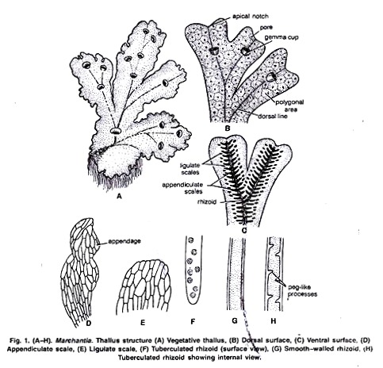
Ventral surface:
The ventral surface of the thallus bears scales and rhizoids along the midrib. Scales are violet coloured, multicellular, one cell thick and arranged in 2-4 rows. Scales are of two types:
(i) Simple or ligulate
(ii) Appendiculate.
Appendiculate scales form the inner row of the scales close with midrib. Ligulate scales form the outer or marginal row and are smaller than the appendiculate scales.
Rhizoids are unicellular, branched and develop as prolongation of the lower epidermal cells. They are of two types:
(i) Smooth-walled rhizoids,
(ii) Tuberculate rhizoids.
In smooth-walled rhizoids both the inner and outer wall layers are fully stretched while in tuber-culate rhizoids appear like circular dots in surface view. The inner wall layer modifies into peg like in growth which projects into the cell lumen. The main functions of the rhizoids are to anchor the thallus on the substratum and to absorb water and mineral nutrients from the soil.
Thallus Structure
Anatomy of the Gametophyte:
A vertical cross section of the thallus can be differentiated photosynthetic zone and lower storage zone.
Internal Structure of the Thallus
a) Upper Photosynthetic zone:
The outermost layer is upper epidermis. Its cells are thin walled square, compactly arranged and contain few chloroplasts. Its continuity is broken by the presence of many barrel shaped air pores. Each pore is surrounded by four to eight superimposed tiers of concentric rings. with three to four cells in each tier.
Air pores are compound in nature. The lower tier consists of four cells which project in the pore and the opening of the pore looks star like in the surface view. The walls of the air pore lie half below and half above the upper epidermis.
Just below the upper epidermis photosynthetic chambers are present in a horizontal layer. Each air pore opens inside the air chamber and helps in exchange of gases during photosynthesis.
These are chambers develop schizogenously (Vocalized separation of cells to form a cavity) and are separated from each other by single layered partition walls. The partition walls are two to four cells in height. Cells contain chloroplast. Many simple or branched photosynthetic filaments arise from the base of the air chambers.
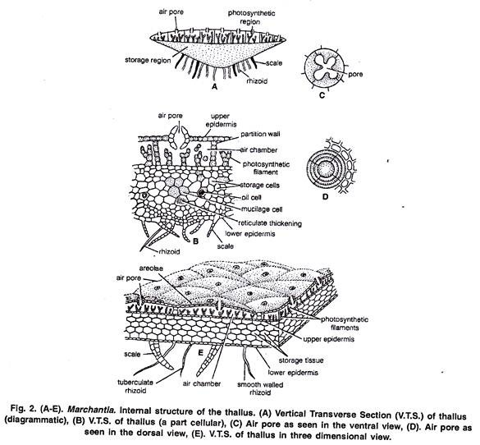
Storage zone:
It lies below the air chambers. It is more thickened in the centre and gradually tapers towards the margins. It consists of several lasers of compactly arranged, thin walled parenchymatous isodiametric cells. Intercellular spaces are absent.
The cells of this zone contain starch. Some cells contain a single large oil body or filled with mucilage. The cells of the midrib region possess reticulate thickenings. The lower most cell layer of the zone forms the lower epidermis. Some cells of the middle layer of lower epidermis extend to form both types of scales and rhizoids.

Reproduction in Marchantia:
Marchantia reproduces by vegetative and sexual methods.
Vegetative Reproduction:
In Marchantia it is quite common and takes place by the following methods:
1. By Gemmae:

Gemmae are produced in the gemma cups which are found on the dorsal surface of the thallus). Gemma cups are crescent shaped, 3 m.m. in diameter with smooth, spiny or fimbriate margins
V. S. passing through the gemma cup shows that it is well differentiated into two regions:
Upper photosynthetic region and inner storage region.
The structure of both the zones is similar to that of the thallus. Mature gemmae are found to be attached at the base of the gemma cup by a single celled stalk.
Intermingled with gemmae are many mucilage hairs. Each gemma is autotrophic, multicellular, bilaterally symmetrical, thick in the centre and thin at the apex. It consists parenchymatous cells, oil cells and rhizoidal cells. It is notched on two sides in which lies the growing point.
Gemma Cup
All cells of the gemma contain chloroplast except rhizoidal cells and oil cells. Rhizoidal cells are colourless and large in size. Oil cells are present just within the margins and contain oil bodies instead of chloroplast.
Dissemination of Gemmae:
Mucilage hairs secrete mucilage on absorption of water. It swells up and presses the gemmae to get detached from the stalk in the gemma cup. They may also be detached from the stalk due to the pressure exerted by the growth of the young gemmae. The gemmae are dispersed over long distances by water currents.
Germination of Gemmae:
After falling on a suitable substratum gemmae germinate. The surface which comes in contact with the soil becomes ventral surface.
The rhizoidai cells develop into rhizoids. Meanwhile, the growing points in which lies the two lateral notches form thalli in opposite directions. Thus, from a single gemmae two thalli are formed. Gemmae which develop on the male thalli form the male plants and those on the female thalli form the female plant.
Development of Gemma:
The gemma develops from a single superficial cell. It develops on the floor of a gemma cup. It is papillate and called gemma initial). It divides by a transverse division to form lower stalk cell and upper cell. The lower cell forms the single celled stalk.
The upper cell further divides by transverse division to form two cells. Both cells undergo by similar divisions to form four cells. These cells divide by vertical and horizontal division to form a plate like structure with two marginal notches. It is called gemma.
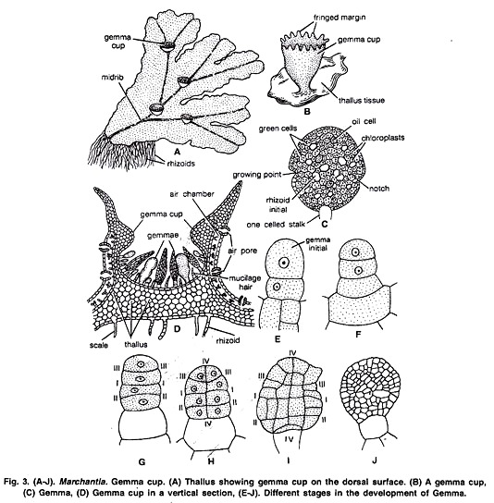

2. Death and decay of the older portion of the thallus or fragmentation:
The thallus is dichotomously branched. The basal part of the thallus rots and disintegrates due to ageing. When this process reaches up to the place of dichotomy, the lobes of the thallus get separated. The detached lobes or fragments develop into independent thalli by apical growth.
3. By adventitious branches:
The adventitious branches develop from any part of the thallus or the ventral surface of the thallus or rarely from the stalk and disc of the archegoniophore in species like M. palmata (Kashyap, 1919). On being detached, these branches develop into new thalli (Fie. 4 D).
Sexual Reproduction:
Sexual reproduction in Marchantia is oogamous. All species are dioecious. Male reproductive bodies are known as antheridia and female as archegonia. Antheridia and archegonia are produced an special, erect modified lateral branches of thallus called antheridiophore and archegoniophore arpocephalum) respectively.
Further growth of the thallus is checked because growing point of the thallus is utilised in the formation of these branches. In some thalli of M. palmatci and L. polymorpha abnormal receptacle bearing both anheridia and archegonia have also been reported, such bisexual receptacles are called as androgynous receptacles.
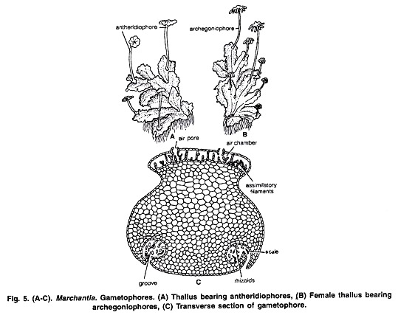
Internal structure of Antheridiophore or Archcgoniophore:
Its transverse section shows that can be differentiated into two sides: ventral side and dorsal side. Ventral side has two longitudinal tows with scales and rhizoids. These grooves, run longitudinally through the entire length of the stalk. Dorsal side shows an internal differentiation of air chambers. (Fig. 5 C).
Antheridiophore:
It consists of 1-3 centimetre long stalk and a lobed disc at the apex (Fig. 32). The disc is usually eight lobed but in M. geminata it is four lobed. The lobed disc is a result of created dichotomies.
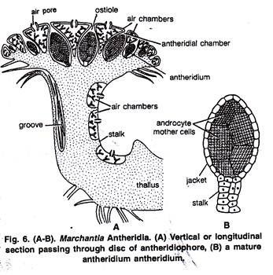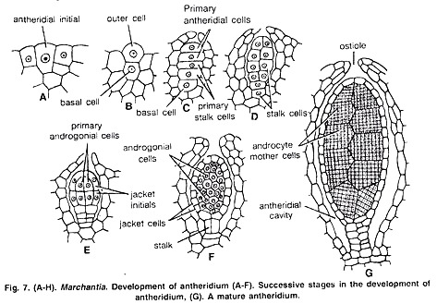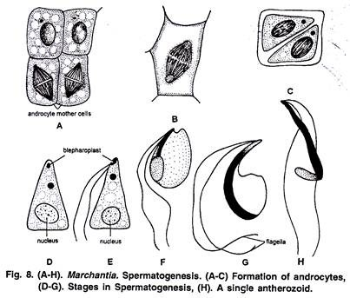
The disc consists of air chambers alternating with heridial cavities. Air chambers are more or less triangular and open on upper surface by n pore Called ostiole. Antheridia arise in acropetal succession i.e., the older near the center and youngest at the margins. (fig. 6 A)
Mature Antheridium:
A mature antheridium is globular in shape and can be differentiated into two parts stalk and body. Stalk is short multicellular and attaches the body to the base of the antheridial chamber. A single layered sterile jacket encloses the mass of androcyte mother cells which metamorphosis into antherozoids (Fig. 6 B, 7 G). The antherozoid is a minute rod like biflagellate structure (Fig. 8 H).
Development of Antheridium:
The development of the antheridium starts by a single superficial cell which is situated on the dorsal surface of the disc, 2-3 cells behind the growing point. This cell is called antheridial initial. The antheridial initial increases in size and divides by a transverse division to form an outer upper cell and a lower basal cell.
Basal cell remains embedded in the tissue of the thallus, undergoes a little further development and forms the embedded portion Of the antheridial stalk. Outer cell divides to form a filament of four cells. Upper two cells of the four celled filament are known as primary antheridial cells and lower two cells are known as primary stalk cells.
Primary stalk cells from the stalk of the antheridium. Primary antheridial cells divide by two successive vertical divisions at right angle to each other to form two tiers of four cells each. A periclinal division is laid down in both the tiers of four cells and there is formation of eight outer sterile jacket initials and eight inner primary androgonial cells.

Development of Antheridium
Jacket initials divide by several anticlinal divisions to form a single layer of sterile antheridial jacket. Primary androgonial cells divide by several repeated transverse and vertical divisions resulting in the formation of large number of small androgonial cells.
The last generation of the androgonial cells is known as androcyte mother cells. Each androcyte mother cells divides by a diagonal mitotic division to form two triangular cells called androcytes. Each androcyte cell metamorphosis into an antheozoid.
Spermatogenesis:
The process of metamorphosis of androcyte mother cells into antherozoids is called spermatogenesis.
Archegoniophore or Carpocephalum:
It arises at the apical notch and consists of a stalk and terminal disc. It is slightly longer than the antheridiophore. It may be five to seven cm. long. The young apex of the archegoniophore divides by three successive dichotomies to form eight lobed rosette like disc.
Each lobe of the disc contains a growing point. The archegonia begin to develop in each lobe in acropetal succession, i.e., the oldest archegonium near the centre and the young archegonium near the apex of the disc. Thus, eight groups of archegonia develop on the upper surface of the disc. There are twelve to fourteen archegonia in a single row in each lobe of the disc.
Development:
The development of the archegonium starts on the dorsal surface of the young receptacle in acropetal succession. A single superficial cell which acts as archegonial initial enlarges and divides by transverse division to form a basal cell or primary stalk cell and an outer cell or primary archegonial cell.
The primary stalk cell undergoes irregular divisions and forms the stalk of the archegonium. The primary archegonial cell divides by three successive intercalary walls or periclinal vertical walls resulting in the formation of three peripheral initials and a fourth median cells, the primary axial cell.
Development of Archegonium
Each of the three peripheral initials divide by an anticlinal vertical division forming two cells. In this way primary axial cell gets surrounded by six cells. These are called jacket initials. Six jacket initials divide transversely into upper neck initials and lower venter initials. Neck initial tier divides by repeated transverse divisions, to form a tube like neck.
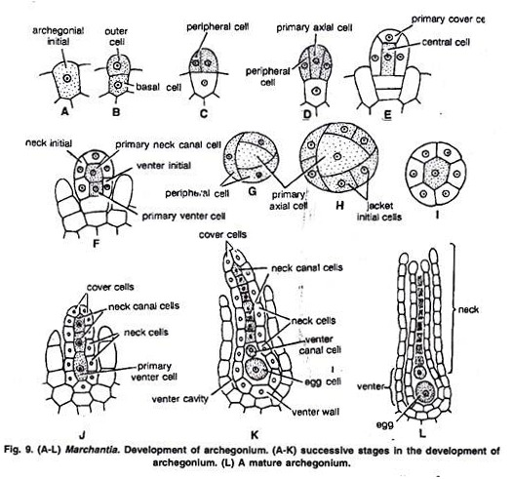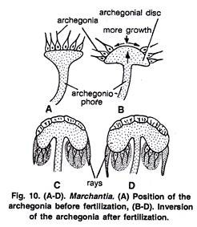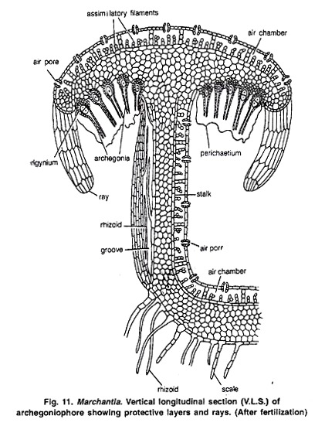
Mature Archegonium:
A mature archegonium is a flask shaped structure. It remains attached to the archegonial disc by a short stalk. It consists upper elongated slender neck and basal globular portion called venter. The neck consists of six vertical rows enclosing eight neck canal cells and large egg. Four cover cells are present at the top of the neck. (Fig 9)
Fertilization in Marchantia:
Marchantia is dioecious. Fertilization takes place when male and female thalli grow near each other. Water is essential for fertilization. The neck of the archegonium is directed upwards on the dorsal surface of the disc of the archegoniophore (Fig. 9 A).
In the mature archegonium the venter canal cell and neck canal cells disintegrate and form a mucilaginous mass. It absorbs water, swells up and comes out of the archegonial mouth by pushing the cover cells apart. This mucilaginous mass consists of chemical substances.
The antherozoids are splashed by rain drops. They may fall on the nearby female receptacle or swim the whole way by female receptacle. It is only possible if both the male and female receptacles are surrounded by water.
Many antherozoids enter the archegonial neck by chemotactic response and reach up to egg. This mechanism of fertilization is called splash cup mechanism. One of the antherozoids penetrates the egg and fertilization is effected. The fusion of both male and female nuclei results in the formation of diploid zygote or oospore. Fertilization ends the gametophytic phase.

Sporophytic Phase:
Post Fertilization Changes:
After Fertilization the following changes occur simultaneously:
1. Stalk of the archegoniophore elongates.
2. Remarkable over-growth takes place in the central part of the disc. As a result of this growth the marginal region of the disc bearing archegonia is pushed downward and inward. The archegonia are now hanging towards the lower side with their neck pointing downwards.
3. Wall of the venter divides to form two to three layered calyptra.
4. A ring of cells at the base of venter divides and re-divides to form a one cell thick collar around archegonium called perigynium (Pseudoperianth).
5. A one celled thick, fringed sheath develops on both sides of the archegonial row. It is called perichaetium or involucre. Thus, the developing sporophyte is surrounded by three protective layers of gametophytic origin i.e., calyptra, perigynium and perichaetium (Fig. 11). The main function of these layers is to provide protection, against drought, to young sporophyte.
6. Between the groups of archegonia, long, cylindrical processes develop from the periphery of disc. These are called rays. They radiate outward, curve downwards and give the disc a stellate form. In M. polymorpha these are nine in number.
7. Zygote develops into sporogonium.

Development of Sporogonium:
After fertilization the diploid zygote or oospore enlarges and it completely fills the cavity of the archegonium. It first divides by transverse division (at right angle to the archegonium axis) to form an outer epibasal cell and inner hypo basal cell (Fig. 12 A, B).
The second division is at right angle to the first and results in the formation of four cells. This represents the quadrant stage (Fig. 12 C). The epibasal cell forms the capsule and hypo basal cells form the foot and seta.
Since the capsule is developed from the epibasal cell and forms the apex of the sporogonium, the type of embryogeny is known as exoscopic. The next division is also vertical and it results in formation of eight celled stage or octant stage.
Now the divisions are irregular and globular embryo is formed (Fig. 12 D). The lower cells divide to form a massive and bulbous foot. The cells of the seta divide in one plane to form vertical rows of cells.
In upper region of capsule (when the young sporogonium is about a dozen or more cells in circumference) periclinal division occurs and it differentiates it into outer single layered amphithecium and multilayered endothecium (Fig. 12 E, F).
The cells of the endothecium divide only by anticlinal divisions to form a single layered sterile jacket or capsule wall. The endothecium forms the archesporium. Its cells divide and re-divide to form a mass of sporogenous cells (sporocytes). Half of the sporogenous cells become narrow and elongate to form the elater mother cells. (Fig. 12 G, I).
In M. polymorpha sporogenous cells divide by five successive divisions to form thirty-two spore mother cells while in M. domingensis sporogenous cells divide only by three to four divisions to form eight or sixteen spore mother cells. The elater mother cells elongate considerably to form long, slender diploid cells called elaters.
Elaters are pointed at both the ends and have two spiral bands or thickenings on the surface of the wall. These are hygroscopic in nature and help in dispersal of spores (Fig. 12 K). The spore mother cell is diploid and divides meiotically to form four haploid spores which remain arranged tetrahedrally for quite some time (Fig. 12 J). The spores later become free and remain enclosed by the capsule wall along elaters. (Fig. 12 H).

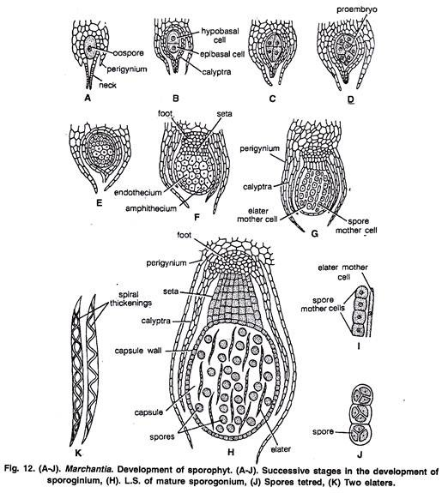Development of Sporophyt

The quadrant type of development of sporogonium is quite common in many species of Marchantia (e.g., M. polymorpha) but in a few species zygote divides by two transverse divisions to form the 3-celled filamentous embryo. In it the hypo basal cell forms the foot, the middle seta and the epibasal cell develops into capsule. However, it is the rare type of embryo development in M. chenopoda.
Mature Sporogonium:
A mature sporogonium can be differentiated into three parts, viz., the foot, seta and capsule (Fig. 13 H).
Foot. It is bulbous and multicellular. It is composed of parenchymatous cells. It acts as anchoring and absorbing organ. It absorbs the food from the adjoining gametophytic cells for the developing sporophyte.
Seta: It connects the foot and the capsule. At maturity, due to many transverse divisions it elongates and pushes the capsule through three protective layers viz., calyptra, perigynium and perichaetium.
Capsule: It is oval in shape and has a single layered wall which encloses spores and elaters. It has been estimated that as many as 3, 00,000 spores may be produced in single sporogonium and there are 128 spores in relation to one elater.

Dispersal of Spores:
As the sporogonium matures, seta elongates rapidly and pushes the capsule in the air through the protective layers (Fig. 13 A). The ripe capsule wall dehisces from apex to middle by four to six irregular teeth or valves. The annular thickening in the cells of the capsule wall causes the valves to roll backward exposing the spores and elaters.
The elaters are hygroscopic in nature. In dry weather they lose water and become twisted. When the atmosphere is wet, they become untwisted and cause the jerking action. Due to this the spore mass loosens and spores are carried out by air currents.
Structure of Spore:
Spores are very small (0.012 to 0.30 mm in diameter). They are haploid, uninucleate, globose and surrounded by only two wall layers. The outer well layer is thick, smooth or reticulate and is known as exospore or exine. The inner wall layer is thin and is called endospore or intine. In M. torsana and M. caneiloba they are tetrahedrally arranged.
Germination of Spores and Development of Gametophyte:
Under favourable conditions, the spores germinate immediately. In first year the spore viability is approximately 100%. Before germination it divides by transverse division to form two unequal cells. The lower cell is small in size.
Marchantia is dioecious, 50% of the spores develop into male thalli and 50% develop into female thalli.

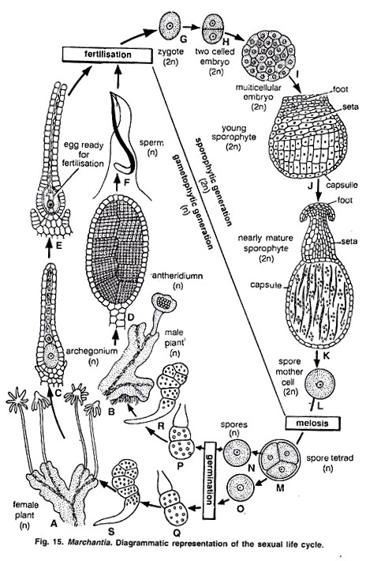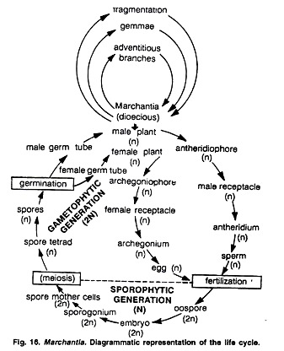
Alternation of Generation in Marchantia:
The life cycle of Marchantia shows regular alternation of two morphologically distinct phases. One of the generations is Haplophase and the other is diplophase.
Haplophase or Gametophytic Phase:
In Marchantia this phase is dominant and produces the sex organs. Sex organs produce gametes to form a diploid zygote.
Diploid Phase or Sporophytic Phase:
Zygote develops into sporophyte. In Marchantia sporophyte is represented by foot, seta and capsule. The sporophyte produces the spores in the capsule. The spores on germination produce the gametophyte.
So, in Marchantia two morphologically distinct phases (Haplophase and Diplophase) constitute the life cycle. The life cycle of this type which is characterised by alternation of generations and sporogenic meiosis is known as heteromorphic and diplohaplontic (Fig. 16).Diagrammatic Representation of the Life Cycle.

