1.6.1 Heating And Cooling of Atmosphere.

The layers of air are heated by contact with the surface of the earth which receives its heat through insolation. The surface of the earth consists of land and water bodies. The different nature of these two divisions of the surface of the earth is responsible for the differential treatment that Insolation receives at the land and water surfaces. This difference is of great importance in the heating of the atmosphere.

Water is fluid and, therefore, reflects the rays of the sun. A large portion of the energy of insolation is lost thereby. Secondly, the rays of the sun are able to penetrate deep into water and the waves and the currents of the water bodies help in scattering the heat received over a greater mass of water. Thirdly, evaporation is always taking place on the surface of water and the after-effect of evaporation is always reducing of the temperature. Hence, due to continuous evaporation, the water masses are less heated. The total of all these factors is that water is heated slowly and four times as much energy is required to heat the water to the temperature of the land masses. In other words the land masses take and lose heat sooner than the water bodies are able to do.

The atmosphere is heated by (1) Direct Insolation Absorption, (2) Conduction (3) convection, (4) compression and (5) radiation.

Distribution of Temperature
Distribution of temperature varies both horizontally and vertically. Let us study it under
- A) Horizontal Distribution of Temperature
- B) Vertical Distribution of Temperature

A) Horizontal Distribution of Temperature
- Distribution of temperature across the latitudes over the surface of the earth is called its horizontal distribution.
- On maps, the horizontal distribution of temperature is commonly shown by isotherms.
- Isotherms are line connecting points that have an equal temperature.
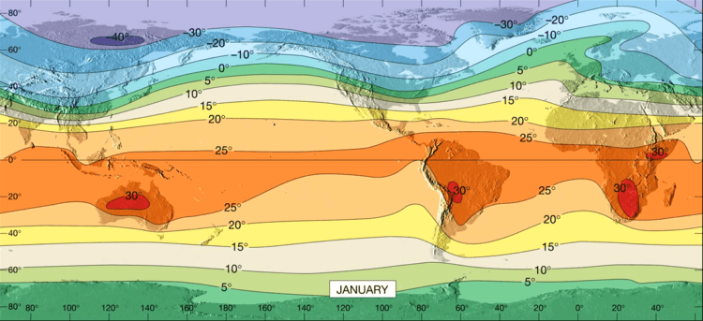
- When we analyse an isotherm map, it can be seen that the horizontal distribution of temperature is uneven.

The factors responsible for the uneven horizontal distribution of temperature are:

1. Latitude
- In the previous article, we have studied that the angle of incidence of sun’s rays goes on decreasing from the equator towards the poles.
- Higher the angle of incidence, higher is the temperature. Similarly, lower the angle of incidence, lower is the temperature.
- This is why the temperature is higher near the tropical regions and decreases towards the poles.
2. Altitude
- As we all know, the temperature in the troposphere goes on decreasing with increase in height.
- Temperature decreases at an average rate of nearly 6 degree Celsius per 1000 m altitude, which is known as Normal Lapse Rate.

3. Land and Sea Contrast
- Compared to land, the sea gets heated slowly and loses heat slowly. Land heats up and cools down quickly.
- As a result, the temperature is relatively higher on land during day time and it is higher in water during the night.
- Also, the places situated near the sea come under the moderating influence of the sea and land breezes which moderates the temperature.
- There are also seasonal variations in the temperature of land and sea. During summer, the air above land has a higher temperature than the oceans. But the air above oceans gets higher temperature than landmass in winter.
- Notwithstanding the great contrast between land and water surfaces, there are differences in the rate of heating of different land surfaces. A snow-covered land as in polar areas warms very slowly because of a large amount of reflection of solar energy. A vegetation covered land does not get excessively heated because a great amount of insolation is used in evaporating water from the plants.

4. Ocean Currents
- Ocean Currents are of two types – warm and cold.
- Warm currents make the coasts along which they flow warmer, while cold currents reduce the temperature of the coasts along which they flow.
- The North-Western European Coasts do not freeze in winter due to the effect of North Atlantic Drift (a warm current), while the Quebec on the coast of Canada is frozen due to the Cold Labrador Current flowing along it, though the Quebec is situated in lower latitudes than the North-West European Coast.
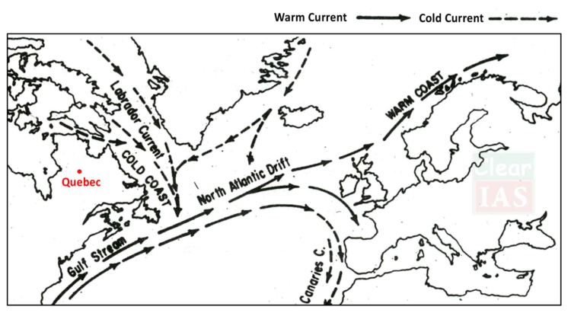

5. Air Masses
- Like the land and sea breezes, the passage of air masses also affects the temperature.
- The places, which come under the influence of warm air masses experience higher temperature and the places that come under the influence of cold air masses experience low temperature.

6. Vegetation Cover
- Soil devoid of vegetation cover receives heat more rapidly than the soil under vegetation cover. Because vegetation cover absorbs much of sun’s heat and then prevents quick radiation from the earth whereas the former radiates it more rapidly.
- Hence the temperature variations in densely forested areas are lower than those in desert areas.
Note: Along with these, the other factors which are responsible for the uneven horizontal distribution of temperature are winds, nature of the soil, slope and aspect of the surface, relief features, etc.
- The horizontal distribution of temperature over the globe can be studied easily from the isotherm maps of January and July months since the seasonal extremes of high and low temperature are most obvious in both northern and southern hemispheres during these months.

B) Vertical Distribution of Temperature
- We have already studied the temperature conditions in different atmospheric layers.
- Temperature in the troposphere decreases with an increase in the altitude.
- This vertical gradient of temperature is commonly referred to as the standard atmosphere or Normal Lapse Rate.
- However, this normal lapse rate varies with height, season, latitude and other factors.
- Indeed the actual lapse rate of temperature does not always show a decrease with altitude.
- In stratosphere, the lower part is isothermal; i.e, there is no change in temperature with height. However, in the Ozone layer temperature increases wit height.
- In mesosphere, the temperature decreases with height and at the mesopause, the temperature reaches -80 degree Celsius.
- Above Mesosphere, lies the thermosphere where temperature increases with height rapidly.

Inversion of Temperature
- The phenomenon in which temperature increases with increasing altitude temporarily and locally under certain conditions is known as inversion of temperature.
- Inversion is usually of short duration but quite common nonetheless.
- Long winter night, clear sky, dry air and absence of winds leads to quick radiation of heat from the earth’s surface, as well as from the lower layers of the atmosphere.
- This results in the cooling of the air near the earth’s surface. The upper layers which lose their heat not so quickly are comparatively warm.
- Hence the normal condition, in which temperature decreases with increasing height, is reversed. The cooler air is nearer the earth and the warmer air is aloft.
- In other words, temperature increases with increasing height temporarily or locally.
- The phenomenon of inversion of temperature is mostly observed in intermountain valleys due to air drainage.
- During winters the mountain slopes cool very rapidly due to the quick radiation of heat.
- The air resting above them also becomes cold and its density increases. Hence, it moves down the slopes and settles down in the valleys.
- This air pushes the comparatively warmer air of valleys upwards and leads to the phenomenon of inversion of temperature.
- Sometimes the temperature falls below freezing point in the valleys leading even to the occurrence of frost. In contrast, the higher slopes remain comparatively warmer.
- This movement of heavy and dense cold air towards the valley slopes almost like water is termed as air drainage

