Reproduction and life cycle
The life cycle of bryophytes consists of an alternation of two stages, or generations, called the sporophyte and the gametophyte. Each generation has a different physical form. When a spore germinates, it usually produces the protonema, which precedes the appearance of the more elaborately organized gametophytic plant, the gametophyte, which produces the sex organs. The protonema is usually threadlike and is highly branched in the mosses but is reduced to only a few cells in most liverworts and hornworts. The protonema stage in liverworts is usually called a sporeling in other bryophytes (see below Form and function).
The gametophyte—the thallose or leafy stage—is generally perennial and produces the male or female sex organs or both. The female sex organ is usually a flask-shaped structure called the archegonium. The archegonium contains a single egg enclosed in a swollen lower portion that is more than one cell thick. The neck of the archegonium is a single cell layer thick and sheathes a single thread of cells that forms the neck canal. When mature and completely moist, the neck canal cells of the archegonium disintegrate, releasing a column of fluid to the neck canal and the surrounding water. The egg remains in the base of the archegonium, ready for fertilization. The male sex organ, the antheridium, is a saclike structure made up of a jacket of sterile cells one cell thick; it encloses many cells, each of which, when mature, produces one sperm. The antheridium is usually attached to the gametophyte by a slender stalk. When wet, the jacket of the mature antheridium ruptures to release the sperm into the water. Each sperm has two flagella and swims in a corkscrew pattern. When a sperm enters the field of the fluid diffused from the neck canal, it swims toward the site of greatest concentration of this fluid, therefore down the neck canal to the egg. Upon reaching the egg, the sperm burrows into its wall, and the egg nucleus unites with the sperm nucleus to produce the diploid zygote. The zygote remains in the archegonium and undergoes many mitotic cell divisions to produce an embryonic sporophyte. The lower cells of the archegonium also divide and produce a protective structure, called the calyptra, that sheathes the growing embryo.
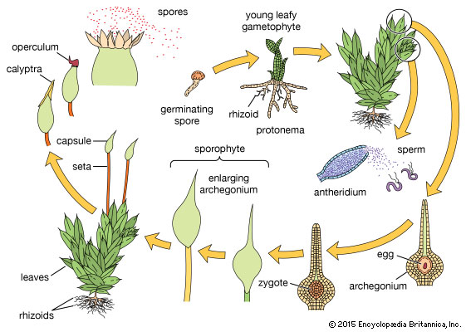
As the sporophyte enlarges, it is dependent on the gametophore for water and minerals and, to a large degree, for nutrients manufactured by the gametophyte. The water and nutrients enter the developing sporophyte through the tissue at its base, or foot, which remains embedded in the gametophyte. Mature bryophytes have a single sporangium (spore-producing structure) on each sporophyte. The sporangium generally terminates an elongate stalk, or seta, when the sporangium is ready to shed its spores. The sporangium rupture usually involves specialized structures that enhance expulsion of the spores away from the parent gametophyte.

Nutrition
Bryophytes generate their nutrient materials through the photosynthetic activity of the chlorophyll pigments in the chloroplasts. In addition, most bryophytes absorb water and dissolved minerals over the surface of the gametophore. Water retention at the surface is assisted by the shape and overlapping of leaves, by an abundance of rhizoids, or by capillary spaces among these structures. Water loss through evaporation is rapid in most bryophytes.
A few bryophytes possess elaborate internal conducting systems (see below Form and function) that transfer water or manufactured nutrients through the gametophore, but most conduction is over the gametophore surface. In most mosses, water and nutrient transfer from the gametophore to the developing sporangium takes place along the seta and also via an internal conducting system. A protective cuticle covers the seta, reducing water loss. The calyptra that covers the developing sporangium prevents water loss in this fragile immature structure. In liverworts the sporangium remains close to the gametophore until it is mature; thus, a conducting system is not formed in the seta. In most hornworts there is also an internal conducting system within the developing horn-shaped sporangium. The internal movement of fluid in all parts of the bryophyte is extremely slow. Storage products include starch and lipids.

