GS/GOGAT PATHWAY
Biosynthesis of amino acids takes place by three ways. The ways are: 1. Ammonium Assimilation, 2. Transamination and 3. Other Methods.
1. Ammonium Assimilation:
(A) Reductive Ammination:
Inorganic nitrogen in the form of NH3 or ammonium (NH4+) produced as a result of reduction of nitrates or biological nitrogen fixation or obtained from the soil, react with a-ketoglutaric acid (an intermediate of Krebs’ Cycle) in the presence of the enzyme glutamic dehydrognase (GDH) and reduced coenzyme NADPH + H to form an amino acid, the glutamic acid (i.e., glutamate) and thus is converted into organic form.
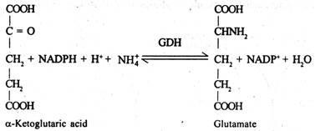
(B) GS/GOGAT – Pathway:
Inorganic nitrogen in the form of ammonium can also be converted into amino acid (i.e., organic form) by sequential actions of two enzymes, glutamine synthetase (GS) and glutamate synthase (also known as glutamine: 2-oxo-glutarate aminotransferase or GOGAT) found in plants.
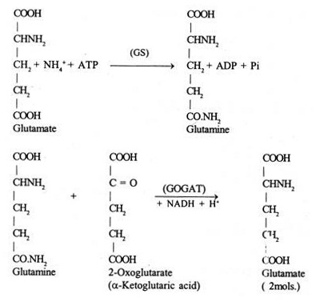
Until recently, the reductive amination of 2-oxoglutarate catalyzed by the enzyme glutamate dehydrogenase has been considered as the main reaction of ammonia assimilation in plants. Now there is convincing evidence that most of the inorganic nitrogen available to a plant is incorporated into the amide amino group of glutamine via the enzyme glutamine synthetase (L-glutamate ammonia ligase— ADP, GS).
Subsequently this amide amino group can be transferred to the 2-position of 2-oxoglutarate yielding 2 moles of glutamate by glutamate synthase (Glutamine: 2-oxoglutarate amino transferase, GOGAT). The GS/GOGAT system has been established to be involved in the process of organic nitrogen interconversion taking place especially in developing germinating seeds during synthesis and mobilization of nitrogenous storage compounds.
This has been established by using N-labelled percursors and in recent studies, the introduction of inhibitors of the assimilation enzyme has proved very valuable to discriminate between the GS/GOGAT and the GDH-pathway.
In heterotrophic tissues, apparently the intracellular distribution of the enzyme involved in nitrogen assimilation corresponds to the pattern observed in green tissues. In root apices of young peas, nitrate reductase was found in the cytosol, nitrite reductase and GOGAT are restricted to the plastids and GS shares a location between cytosol and plastid; GDH was only detected in the mitochondria though in other heterotrophic tissues, it is also reported from plastids.
Most enzymes from heterotrophic tissues are active with both nicotinamide nucleotides, and seem to prefer NAD+ as also reported in pollen grains. Figure 11-5 shows summary of nitrogen fixation.
2. Transamination:
The various other amino acids which ultimately condense to form proteins are produced by transamination reactions involving the transfer of amino group from glutamic acid to the keto position of the corresponding keto acid.
Amino group from other amino acids except glutamic acid may also be transferred to other keto acids forming corresponding amino acids. Transamination reactions take place in the presence of enzymes transminases (aminotransferases) which require coenzyme pyridoxal phosphate (a derivative of vitamin B6 i.e., pyridoxine).
The coenzyme pyridoxal phosphate acts as carrier of amino group. It picks up the amino group from the donor amino acid and is converted into pyridoxamine phosphate. The latter transfers this amino group to the acceptor keto acid forming a new amino acid and itself is converted into pyridoxal phosphate
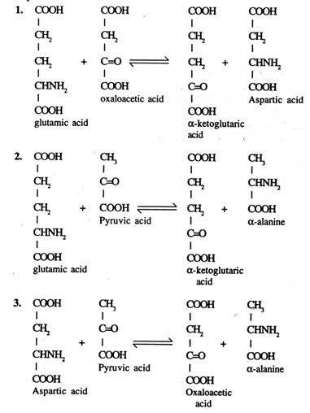
3. Other Methods:
Amino acids may also be produced by the transformation of acid amides and other nitrogenous compounds or by the hydrolysis of proteins by proteolytic enzymes.

