Bryophytes
The division Bryophyta (Gr. bryon=moss) includes over 25000 species of non-vascular embryophytes such as mosses, liverworts and hornworts.
Bryophytes are small plants (2cm to 60cm) that grow in moist shady places. They don’t attain great heights because of absence of roots, vascular tissues, mechanical tissues and cuticle. They are terrestrial but require external water to complete their life cycle. Hence, they are called “Amphibians of plant kingdom”.
The fossil record indicates that bryophytes evolved on earth about 395 – 430 million years ago (i.e. during Silurian period of Paleozoic era). The study of bryophytes is called bryology.
Salient features of Bryophytes:
1. Bryophytes grow in damp and shady places.
2. The plant body of bryophyte is gametophyte and is not differentiated into root, stem and leaf like structure.
3. Most of them are primitive land dwellers. Some of them are aquatic (Riella, Ricciocarpus).
4. They follow heterologous haplodiplobiontic type of life cycle.
5. The dominant plant body is gametophyte on which sporophyte is semiparasitic for its nutrition.
6. The thalloid gametophyte differentiated in to rhizoids, axis (stem) and leaves.
7. Vascular tissues (xylem and phloem) absent, hence called ‘Non vascular cryptogams’.
8. Vegetative reproduction takes place by the formation of adventitious buds (Riccia fluitans) tubers develop in Anthoceros. In some forms small detachable branches or brood bodies are formed, they help in vegetative reproduction as in Bryopteris fruticulosa.
9. In Marchantia propagative organs called gemmae are formed and help in reproduction.
10. The gametophyte bears multi-cellular and jacketed sex organs (antheridia and archegonia).
11. Sexual reproduction is oogamous type. Antheridia and Archegonia are produced in a protective covering and are multicellular
12. The antheridia produces biflagellate antherozoids which swims in thin film of water and reach the archegonium and fuse with the egg to form diploid zygote.
13.Water is essential for fertilization.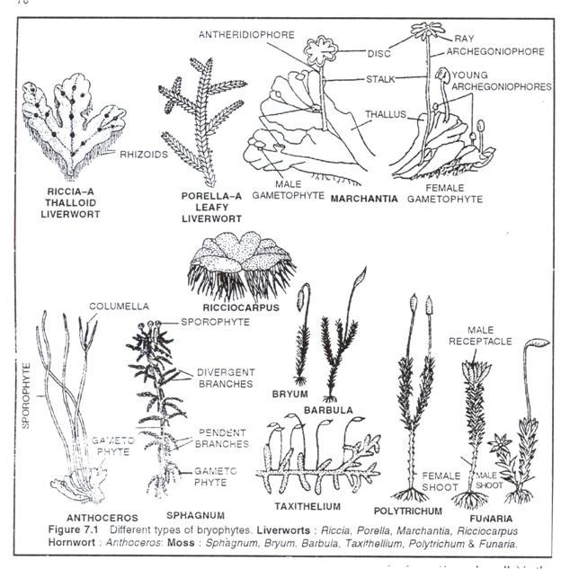

14. Multi-cellular embryo develops inside archegonium.
15. The zygote, embryo and the sporogonium constitute sporophytic phase. The green long living haploid phase is called gametophytic phase.
16. The haploid gametophytic phase alternates with diploid sporophyte and shows heterologous alternation of generation.
17. The sporophyte is dependent on gametophyte.
18. Sporophyte differentiated into foot, seta and capsule. Foot is the basal portion and is embedded in the gametophyte through which water and nutrients are supplied for the sporophyte.
19. The diploid spore mother cells found in the capsule region undergoes meiotic division and give rise to haploid spores.
20. Bryophytes are homosporous. Capsule produces haploid meiospores of similar types (homosporous).
21. In some sporophytes elaters are present and help in dispersal of spores (Example: Marchantia).
22. The spores germinate to produce gametophyte.
23. Spore germinates into juvenile gametophyte called protonema.
24. The zygote is the first cell of the sporophyte generation. It undergoes mitotic division to form multicellular undifferentiated embryo.
25. The embryogeny is exoscopic (the first division of the zygote is transverse and the apex of the embryo develops from the outer cell) .
26. The embryo divides and give rise to sporophyte.
27. Progressive sterilization of sporogenous tissue noticed from lower to higher bryophytes.
28. Bryophytes are classified under three classes: Hepaticae (Liverworts), Anthocerotae (Hornworts) and Musci (Mosses).

The gametophyte is conspicuous, long lived phase of the life cycle. Thalloid forms are present in liverworts and Hornworts. In Mosses leaf like, stem like structures are present. In Liverworts thallus grows prostrate on the ground and is attached to the substratum by means of rhizoids. Two types of rhizoids are present namely smooth walled and pegged. Multicellular scales are also present. In Moss the plant body is erect with central axis bearing leaf like expansions. Multicellular rhizoids are present.
