Gnetum
There are about 40 species in one genus, Gnetum,
Description
- Dioecious, evergreen, mostly woody vines, rarely shrubs or trees; of which some species are trees (Gnetum gnemon), many are lianes or shrubs and a few. are stumpy turnip-like (e.g. Welwitschia mirabilis).
- stems with swollen nodes.
- Leaves opposite, petiolate, without stipules, simple, elliptic, with pinnate veins and entire margins; usually with drip tips.
- Vessels are present in the secondary wood.
- ‘Flowers’ are unisexual, usually dioecious and only rarely monoecious as in some species of Gnetum
- Flowers’ are arranged in compound strobili or ‘inflorescences’.
- Both male and female megastrobili terminal or lateral, sometimes arranged in dense, cauliflorous clusters on old stems.
- Each megastrobilus consists of a straight axis above a basal pair of opposite, connate bracts; the axis bears usually three to six superposed cupules, each of which contains several to many male or female strobili.
- The male strobilus consists of a stamen and perianth, the female strobilus of an ovule with 2 integuments and perianth.
- Nucellus of the ovule remains surrounded by two or three envelopes.
- The micropyle of each ovule remains projected in the form of a long bristle-like tube.
- At the time of fertilization the pollen tube contains two male nuclei.
- A unicellular primary suspensor is present in the embryo.
- Seeds drupelike, enclosed in a red, orange, or yellow, fleshy (rarely corky)
- false seed coat; female gametophyte tissue copious, succulent.
- Cotyledons 2.
- Germination epigeal.
- The wood contain tracheids and is otherwise typical of gymnosperms, but also contains vessels, another angiosperm trait, thought in this case to have arisen independently, without phylogenetic significance.
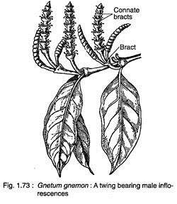
Distribution of Gnetum:
Gnetum, represented by about 40 species is confined to the tropical and humid regions of the world. Nearly all species, except G. microcarpum, occur below an altitude of 1500 metres. Five species (Gnetum contractum, G. gnemon, G. montanum, G. ula and G. latifolium) have been reported from India. Gnetum ula is the most commonly occurring species of India.
According to Bhardwaj (1957) various species of Gnetum occur in India in the following regions:
- Gnetum ula: It is a woody climber having branches with swollen nodes. It is found in Western Ghats near Khandala, forests of Kerala, Nilgiris, Godawari district of Andhra Pradesh and Orissa.
- Gnetum contractum: A scandent shrub growing in Kerala, Nilgiri Hills and Coonoor in Tamil Nadu.
- Gnetum gnemon: A shrubby plant found in Assam (Naga-Hills, Golaghat and Sibsagar).
- Gnetum montanum: A climber with smooth, slender branches, swollen at the nodes. It is found in Assam, Sikkim and parts of Orissa.
- Gnetum latifolium: A climber found in Andaman and Nicobar Islands.

Classification of Gnetales:
Sporne (1965) divided Gnetales into following three unigeneric families:
(i) Gnetaceae: Gnetum
(ii) Ephedraceae: Ephedra
(iii) Welwitschiaceae: Welwitschia
The ‘Gnetales’ comprise a small group of plants—Gnetum, Welwitschia and Ephedra and they seem to form a connecting link between gymnosperms and angiosperms. They are characterized by their extraordinary morphology and diverse habit.
Morphological evidence strongly supports a break-up of the old Order with the setting up of three families (Ephedraceae, Welwitschiaceae, Gnetaceae) and the establishment of three Orders Ephedrales, Welwitschiales and Gnetales. Ephedrales have phylogenetic relationships to the Welwitschiales and the Gnetales. Stomatal apparatus of Ephedra belongs to a primitive basic type different from that of Welwitschia and Gnetum.
In the structure of the cone, in nodal anatomy, in primary stem structure and in wood structure Ephedra differs from the other two genera. Ovule position and morphology of the fertile shoot of the Ephedra suggest relationship of Ephedrales to Cordaites stock or to an ancestral stock common to Cordaites and Conifers.
The order includes only one family Gnetaceae. Person records about 66 species under Gnetales—35 species for Ephedra, 30 for Gnetum, and only 1 for Welwitschia.
Anatomy of Gnetum:
(i) Root:
Young root has several layers of starch-filled parenchymatous cortex, the cells of which are large and polygonal in outline. An endodermal layer is distinguishable. Casparian strips are seen in the cells of the endodermis. The endodermis follows 4-6 layered pericycle. Roots are diarch and exarch. Small amount of primary xylem, visible in young roots, becomes indistinguishable after secondary growth.
The secondary growth is of normal type. A continuous zone of wood is present in the old roots. It consists of tracheids, vessels and xylem parenchyma. The tracheids have uniseriate bordered pits along with bars of Sanio.
Vessels have simple or small multiseriate bordered pits. Some of the xylem elements have starch grains. Bars of Sanio are generally absent in the vessels. Phloem consists of sieve cells and phloem parenchyma.
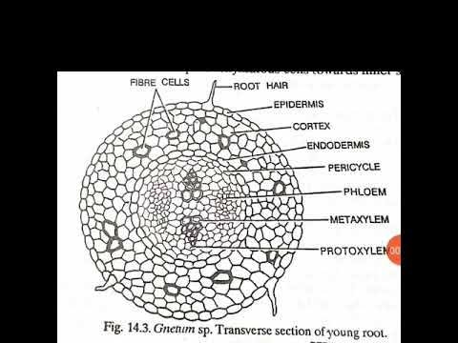
(ii) TS of Stem:
The young stem in transverse section is roughly circular in outline, and resembles with a typical dicotyledonous stem. It remains surrounded by a single-layered epidermis, which is thickly circularized and consists of rectangular cells. Some of the epidermal cells show papillate outgrowths. Sunken stomata are present.
The cortex consists of outer 5-7 cells thick chlorenchymatous region, middle few-cells thick parenchymatous region and inner 2-4 cells thick sclerenchymatous region. Endodermis and pericycle regions are not very clearly distinguishable. Several conjoint, collateral, open and endarch vascular bundles are arranged in a ring (Fig. 13.5) in the young stem.
Xylem consists of tracheitis and vessels. Presence of vessels is an angiospermic character. Protoxylem elements are spiral or annular while the metaxylem shows bordered pits which are circular in outline. The phloem consists of sieve cells and phloem parenchyma. An extensive pith, consisting of polygonal, parenchymatous cells, is present in the centre of the young stem.
Old stems in Gnetum show secondary growth. In G. gnemon the secondary growth is normal, as seen also in the dicotyledons. But in majority of the species (e.g., G. ula, G. africanum, etc.) the anamolous secondary growth is present.
The primary cambium is ephemeral, i.e., short-lived. The secondary cambium in different parts of cortex develops in the form of successive rings, one after the other (Fig. 13.6). The first cambium cuts off secondary xylem towards inside and secondary phloem towards outside. This cambium ceases to function after some time.
Another cambium gets differentiated along the outermost secondary phloem region, and the same process is repeated. In the later stages, more secondary xylem is produced on one side and less on the other side, and thus the eccentric rings of xylem and phloem are formed in the wood.
This type of eccentric wood is the characteristic feature of angiospermic lianes. The periderm is thin and develops from the outer cortex. It also possesses lenticels. The cortex also contains chlorenchvmatous and parenchymatous tissues along with many sclereids.

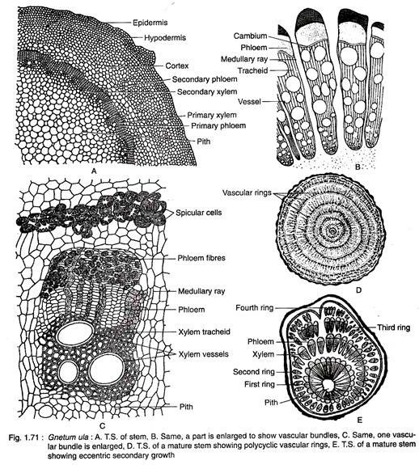

(iv) Leaf:
Internally, Gnetum leaves also resemble with a dicot leaf. It is bounded by a layer of thickly circularized epidermis on both the surfaces. Stomata are distributed all over the lower surface except on the veins. The mesophyll is differentiated generally into a single-layered palisade and a well-developed spongy parenchyma.
The latter consists of many loosely-packed cells. Many stellately branched sclereids are present near the lower epidermis in the spongy parenchyma. Many stone cells and latex tubes are present in the midrib region of the leaf.
Several vascular bundles in the form of an arch or curve are present in the prominent midrib region. A ring of thick-walled stone cells is present just outside the phloem. Each vascular bundle is conjoint and collateral.
The xylem of each vascular bundle faces towards the upper surface while the phloem faces towards the lower surface. The xylem consists of tracheids, vessels and xylem parenchyma while the phloem consists of sieve cells and phloem parenchyma.

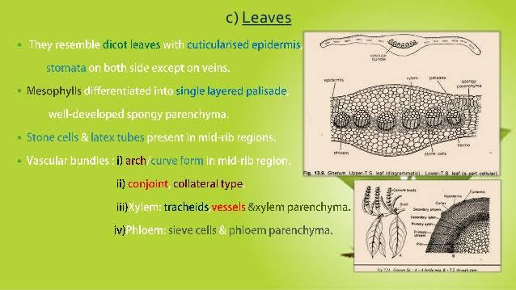
. Reproduction of Gnetum:
Gnetum is dioecious. The reproductive organs are organised into well-developed cones or strobili. These cones are organised into inflorescences, generally of panicle type. Sometimes the cones are terminal in position.
A cone consists of a cone axis, at the base of which are present two opposite and connate bracts. Nodes and internodes are present in the cone axis. Whorls of circular bracts are present on the nodes. These are arranged one above the other to form cupulas or collars). Flowers are present in these collars. Upper few collars may be reduced and are sterile in nature in G. gnemon.
Male Cone and Male Flower:
The male flowers are arranged in definite rings above each collar on the nodes of the axis of male cone. The number of rings varies between 3-6. The male flowers in the rings are arranged alternately. There is a ring of abortive ovules or imperfect female flowers above the 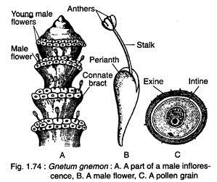rings of male flowers.
Each male flower contains two coherent bracts which form the perianth). Two unilocular anthers remain attached on a short stalk enclosed within the perianth. At maturity, when the anthers are ready for dehiscence, the stalk elongates and the anthers come out of the perianth sheath. In Gnetum gnemon a few (2-3) flowers are sometimes seen fusing each other.
Development of Male Flower
In very young cones, certain cells below each collar become meristematic. They divide repeatedly and form a small hump-like outgrowth. Certain cells on the upper side of this annular outgrowth start to differentiate into the initials of the ovules. They develop into abortive ovules which form the uppermost ring. The cells of the lower side of this annular outgrowth form the primordium of male flower.
A central cushion of cells develops by the repeated divisions in the male flower primordium. This cushion gets surrounded by a circular sheath called perianth. The sheath-like perianth encloses the central cushion-like mass only partially. With the development of a depression or notch in the central mass two lobes differentiate and later on develop into two anther lobes.
With the help of many divisions the basal portion of this central mass of cells starts to differentiate into a stalk. This stalk elongates and pushes the anther lobes towards the outer side. Each anther lobe remains surrounded by an epidermal layer and a few wall layers which enclose a microsporangium.The innermost wall layer enclosing the sporogenous tissue is known as tapetum.
The sporogenous cells become loose, contract, round up and change into the spore mother cells. In the process of microspore formation the tapetum and two wall layers are used for the developing microspores. The spore mother cells undergo meiosis and ultimately the spore tetrads are formed.
The characteristic radial thickenings develop in the epidermal cells. They help in the dehiscence of microsporangium. The microspores are ornamented.

Female Cone:
The female cones resemble with the male cones except in some definite aspects. A single ring of 4-10 female flowers or ovules is present just above each collar (Fig. 13.15). Only a few of the ovules develop into mature seeds.
In the young condition, there is hardly any external difference between female and male cones. All the ovules are of the same size when young but later on a few of them enlarge and develop into mature seeds. All the ovules never mature into seeds.
Ovule or Female Flower:
Each ovule consists of a nucellus surrounded of three envelopes. The nucellus consists of central mass of cells. The inner envelope elongates beyond the middle envelope to form the micropylar tube or style. The nucellus contains the female gametophyte. There is no nucellar beak in the ovule of Gnetum.
Stomata, sclereids and laticiferous cells are present in the two outer envelopes. Madhulata (1960) observed the formation of a circular rim from the outer epidermis of the inner integument in G. gnemon. Thoday (1921), however, observed the formation of a second such rim at a higher level. The ovules in G. ula are stalked.

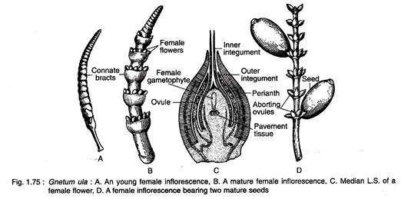

Morphological Nature of Three Envelopes:
Several different views have been given by many different workers regarding the morphological nature of the three envelopes surrounding the nucellus.
A few of them are under mentioned:
(i) According to Strasburger (1872) three envelopes of nucellus are integuments developing from the differentiation of single integument.
(ii) Baccari (1877) opined that the outer envelope is a perianth while the inner two envelopes are integuments.
(iii) Van Tieghem (1869) considered the two inner envelopes as the integuments while the outer envelope as an ovary or analogous to it.
(iv) According to Lignier and Tison (1912), however, the outer two envelopes form a perianth while the inner envelope is equivalent to an angiospermic ovary. Vasil (1959) also supported the view of Lignier and Tison (1912) in case of Gnetum ula.

Mega-Sporangium, Mega-Sporogenesis and Female Gametophyte:
Four to ten ovular primordia differentiate on the annular meristematic ring. This ring develops below each collar of the female cone in the same manner as that of the male cone. The ovular primordium divides and re-divides several times to form a mass of cells.
All the three envelopes of the female flower develop around this mass of cells The innermost third envelope remains fused with the nucellus at the base while its upper portion remains free and form the long micropylar tube or ‘style’.
In the young conditions, an outer epidermal layer is distinguishable in the nucellus. Two to four archesporial cells develop below the epidermis at a later stage. The archesporial cells divide periclinally to form outer primary’ parietal cells and inner sporogenous cells. The primary parietal cells and the epidermal layer divide periclinally and anticlinally several times resulting into a massive nucellus.
The sporogenous cells divide and re-divide to form megaspore mother cells which remain arranged in linear rows. All the megaspore mother cells may divide reductionally and form tetrasporic embryo-sacs but ultimately all, except one, degenerate.
As many as 256 (Gnetum gnemon) to 1500 (G. ula) free-nuclei are formed in the female gametophyte leaving a vacuole in the centre (Fig. 13.18). The female gametophyte is tetrasporic in development. It is broader towards the micropylar end and it tapers towards the chalazal end.
The nuclei near the chalazal end get surrounded by cell walls while those towards micropylar end remain free. Gametophyte is thus partly cellular and partly-nuclear. The archegonia are absent in Gnetum.
Certain nuclei near the micropylar end start to function as egg nuclei. According to Swamy (1973) the only nucleus in a uninucleate cell or one of the nuclei in a multinucleate cell enlarges and functions as the egg in G. ula. The nucellar beak is absent in Gnetum.

Microsporangium and Micro-Sporogenesis:
Development of the microsporangium can be studied only in young anthers. Two archesporial cells are distinguished below the epidermal layer. Archesporial cells divide and re-divide to form many-celled archesporium. The outermost layer of the archesporium divide periclinally to form an outer layer of parietal cells and inner layers of sporogenous cells.
The parietal cells form the wall layers and tapetal layer by periclinal divisions. The sporogenous cells develop into microspore mother cells by some irregular divisions. Tapetal cells later on become bi-nucleate. Microspore mother cells divide reductionally to form haploid microspores.
The microspores may be arranged in isobilateral, decussate or tetrahedral manner in their earlier stages. Side by side the wall cells and the tapetal cells degenerate and ultimately dis-organise. The epidermal cells become thick, cutinized and radially elongated.
Many fibrous thickenings also develop in these cells. Small globular structures are present on the inner surface of the epidermis in Gnetum ula and G. gnemon. Anthers dehisce along a double row of small cells which extends from the tip towards the base.
Male Gametophyte:
Pollen grains or microspores are roughly spherical in outline. They are uninucleate and remain surrounded by a thick and spiny exine and thin intine. Mature pollen grains are shed at three-nucleate stage. These include prothallial nucleus, tube nucleus and generative nucleus in Gnetum Africanism and G. gnemon according to Pearson (1912).
This three-nucleate stage is reached by first dividing the microspore nucleus mitotically into two and then one of them again gets divided. Further development is affected only in the pollen chamber. The intine comes out by rupturing the exine and forms a pollen tube.
The tube nucleus migrates into the pollen tube. The generative nucleus also adopts the same course and divides into two unequal male gametes in the tube. Prothallial nucleus does not enter the pollen tube.

Pollination:
Wind helps in carrying the pollen grains up to the micropylar tube of the ovule. The micropylar tube secretes a drop of fluid in which certain pollen grains get entangled and reach up to the pollen chamber. The nucellus cells below the pollen chamber are full of starch.
Fertilization:
The fertilization in Gnetum has been studied only by a few workers. Vasil (1959) studied this phenomenon in G. ula. At the time of fertilization, the pollen tube pierces through the membrane of the female gametophyte just near to a group of densely cytoplasmic cells. The tip of pollen tube bursts and the male cells are released. One of the male cells enters the egg cell.
The male and female nuclei, after lying side by side for some time, fuse with each other and form the zygote. According to Swamy (1973), the only identifying features of the zygote are its spherical shape and dense cytoplasm. Both the male cells of a pollen tube may remain functional if two eggs are present close to the pollen tube.
Endosperm:
In all gymnosperms, except Gnetum, a cellular endosperm develops before fertilization. In Gnetum, the cell formation, although starts before fertilization, a part of the gametophyte remains free-nuclear at the time of fertilization.
After fertilization the wall formation in the female gametophyte starts in such a way that the cytoplasm gets divided into many compartments. Each of these compartments contains many nuclei.
All the nuclei of one compartment fuse and form a single nucleus. The wall formation starts from the base and proceeds upwards. The wall formation varies greatly in Gnetum. Only the lower portion of the gametophyte may become cellular leaving the remaining upper portion free-nuclear. Sometimes the entire gametophyte may become cellular.
The Embryo
Thompson (1916) opined that a two-celled pro-embryo is formed. From each of these two cells develops a tube called suspensor. Now the nucleus divides and one of the two nuclei undergoes free-nuclear divisions forming four nuclei. The embryo gets organised by these four nuclei. There is no division in the other larger nucleus..
Seed:
Gnetum seeds are oval to elongated in shape and green to red in colour. It remains surrounded by a three-layered envelope which encloses the embryo and the endosperm. Outer envelope is fleshy, and consists of parenchymatous cells. It imparts colour to the seed.
The middle envelope is hard, protective and made up to three layers, i.e., outer layer of parenchymatous cells, middle of palisade cells and innermost fibrous region. The inner envelope is parenchymatous. Branched vascular bundles traverse through all the three envelopes.
. Relationships of Gnetum:
Gnetum and Other Gymnosperms:
Gnetum shows several resemblances with gymnosperms and has, therefore, been finally included under this group. Some of the characteristics common in both Gnetum and other gymnosperms are under mentioned:
1. Wood having tracheids with bordered pits.
2. No sieve tubes and companion cells are present.
3. Presence of naked ovules.
4. Absence of fruit formation because of the absence of ovary.
5. Anemophilous type of pollination.
6. Development of prothallial cell.
7. Cleavage polyembryony.
8. Resemblance of the vascular supply of the peduncle of the cone of Cycadeoidea wielandii with that of a single flower of Gnetum.
9. Resemblance of the structure of basal part of the ovule in Gnetum and Bennettites.

Gnetum and Angiosperms:
A key position to Gnetum has been assigned by scientists while discussing the origin of angiosperms. Both Gnetales and angiosperms originated from a common stalk called “Hemi-angiosperm”.
Thompson (1916) opined that the ancestors of both Gnetum and angiosperms were close relatives. Some other workers have gone up to the extent in stating that Gnetum actually belongs to angiosperms. Hagerup (1934) has shown a close relationship between Gnetales and Piperaceae.
In a beautiful monograph on Gnetum, Maheshwari and Vasil (1961) have stated that “Gnetum remains largely a phylogenetic puzzle. It is gymnospermous, but possesses some strong angiospermic features”.
Some of the resemblances between Gnetum and angiosperms are under mentioned ( Angiospermic characters of Gnetum):
1. The general habit of the sporophyte of many species of Gnetum resembles with angiosperms.
2. Reticulate venation in the leaves of Gnetum is an angiospermic character.
3. Presence of vessels in xylem is again an angiospermic character.
4. Clear tunica and corpus configuration of shoot apices is a character of both Gnetum and angiosperms.
5. Strobili of Gnetum resemble much more with angiosperms than any of the gymnosperms
6. Micropylar tube of Gnetales can be compared with the style of the angiosperms because both perform more or less similar functions.
7. Tetrasporic development of the female gametophyte is again a character which brings Gnetum close to angiosperms.
8. Absence of archegonia again brings Gnetum and angiosperms much closer.
9. Dicotyledonous nature of the embryo of Gnetum brings it quite close to the dicotyledons.
Among the angiospermic features are:
(1) The compound nature of both the microsporangiate and megasporangiate strobili, which are similar to the inflorescences of angiosperms.
(2) The presence of vessels in the xylem.
The relation of the three genera to any known angiosperm is highly improbable and their affinities with modern gymnosperms seem equally obscure. The leaves of the three genera differ widely in size, form and venation. In Ephedra the leaves are scale-like, basically fused to form a sheath.
The leaves of Welwitschia are long and strap-shaped. Gnetum is particularly unusual among gymnosperms, because of pinnate reticulate venation (angiosperm-like). Regarding stomata Ephedra are haplocheilic as in most gymnosperms, whereas syndetocheilic stomata occur in both Gnetum and Welwitschia.
Evolution of vessels in angiosperms and the Gnetales illustrates parallel evolution and there is no evidence of phyletic relationship between the two groups of plants.
In all members of the Gnetales, the micro-and megasporangiate strobili are compound. In all gnetalean plants the single true integument of the ovule becomes elongated as a tube.
While Ephedra has an archegonium, the complex female gametophytes of both Gnetum and Welwitschia are devoid of archegonia.
The members of Gnetales are specialized endpoints in evolution which are not closely related to any present-day gymnosperms or angiosperms.
No fossil record the Gnetales have been obtained below the Tertiary, and consequently, the order may be regarded as a com­paratively younger one. The members of this order-occur both in the Eastern as well as in the Western Hemispheres, excepting welwitschia mirabilis, which is practically endemic to the Namib desert area of South-West Africa.
Plants woody, sparsely branched and usually dioecious; leaves simple, opposite and net-veined like those of the dicotyledons; ‘flowers’ with a distinct perianth and generally forming cones; embryo with two cotyledons; endosperm copious; true vessels present in the secondary wood; resin canals absent.

Resemblances Between Gnetum, Ephedra and Welwitschia:
All the three genera of Gnetales show following resemblances:
(1) Opposite leaves;
(2) Vessels in their secondary wood,
(3) Similar structure and development of perforation plates in their vessels
(4) Similar Gnetalean mode of development of their vessels i.e. by the dissolution of torus and middle lamella of the bordered pits;
(5) Almost similar structure of their sieve cells and phloem parenchyma;
(6) Spiral or annular elements in their protoxylem;
(7) Arrangement of their flowers in compound strobili;
(8) Unisexual flowers;
(9) Dioecious plants;
(10) Stalked male flowers bearing synangia made of 1-6 or more sporangia;
(11) Almost consistent structure of the wall of their microsporangia;
(12) Wingless pollen grains;
(13) Orthotropous ovules;
(14) Ovules surrounded by several envelopes which are interpreted variously as integuments or perianth;
(15) Extremely elongated micropylar tube;
(16) Formation of unicellular primary suspensors;
(17) Dicotyledonous embryo;
(18) Simple type of polyembryony..

Ethnobotany
Ethnopharmacological studies have found C-glycosyl-flavones; and a group of complex stilbenes and stilbene-substituted benzofurans. Gnetol, a hydroxylated stilbene, occurs in G. ula. "Lignans are of the guaiacyl-syringyl-type; the antiasthmatic properties for which G. parviflorum is used in Chinese medicine have been ascribed to the presence of demethylcoclaurine hydrochloride" (Schultes and Raffauf 1990).

