Biogeography meaning

Biogeography, the study of the geographic distribution of plants, animals, and other forms of life. It is concerned not only with habitation patterns but also with the factors responsible for variations in distribution.
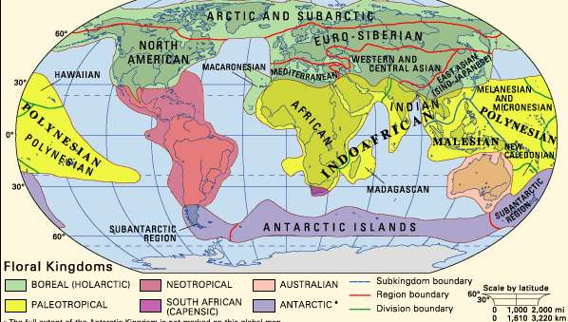
Earth's floral regions

Strictly speaking, biogeography is a branch of biology, but physical geographers have made important contributions, particularly in the study of flora. Modern advancements in the classification of vegetation and the preparation of maps of vegetation began in the 20th century with the work of American botanists Forrest Shreve, Homer L. Shantz, Hugh M. Raup, and others.
Biogeographic studies divide Earth’s surface—primarily the continents and islands—into regions exhibiting differences in the average composition of flora and fauna. It is thought that the present-day distribution patterns of plant and animal forms, as reflected in such biogeographic regions, are the result of many historical and current causes. These causes include present climatic and geographic conditions, the geologic history of the landmasses and their climates, and the evolution of the taxon (e.g., genus or species) involved. Investigators have found that rate of dispersal, adaptability to prevailing environmental condition have a significant impact on pattern and extent of distribution.
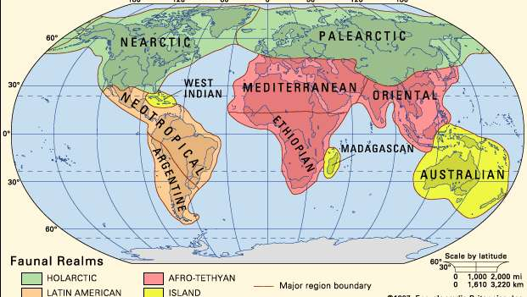
Earth's faunal regions

