PINUS

External Morphology of Pinus:
1. Pinus is a large, perennial, evergreen plant.
2. Branches grow spirally and thus the plant gives the appearance of a conical or pyramidal structure.
3. Sporophytic plant body is differentiated into roots, stem and acicular (needle-like) leaves
4. A tap root with few root hair is present but it disappears soon. Later on many lateral roots develop, which help in absorption and fixation.
5. The ultimate branches of these roots are covered by a covering of fungal hyphae called ectotrophic mycorrhiza.
6. The stem is cylindrical and erect, and remains covered with bark. Branching is monopodial.
7. Two types of branches are present: long shoots and dwarf shoots. These are also known as branches of unlimited and limited growth, respectively.
8. Long shoots contain apical bud and grow indefi­nitely. Many scaly leaves are present on the long shoot.
9. Dwarf shoots are devoid of any apical bud and thus are limited in their growth. They arise on the long shoot in the axil of scaly leaves.
10. A dwarf shoot has two scaly leaves called prophylls, followed by 5-13 cataphylls arranged in 2/5 phyllotaxy, and 1-5 needles.
11. The leaves are of two types, i.e., foliage and scaly.
12. Scaly leaves are thin, brown-coloured and scale like and develop only on long as well as dwarf shoots.
13. Foliage leaves are present at the apex of the dwarf shoots only.
14. Foliage leaves are large, needle-like, and vary in number from 1 to 5 in different species.
15. A spur is called unifoliar if only one leaf is present at the apex of the dwarf shoot, bifoliar if two leaves are present, trifoliar if three leaves are present, and so on.

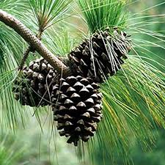

T.S. Young Root:
1. Outermost layer of the circular roots is thick-walled epiblema with many root hair.
2. Epiblema is followed by many layers of parenchymatous cortex.
3. Inner to the cortex is present a layer of endodermis and many layers of pericycle.
4. Vascular bundles are radially arranged and diarch to tetrarch with exarch protoxylem.
5. Protoxylem is bifurcated (Y-shaped) towards the periphery, and in between each bifurcation is present a resin cannal.
6. Phloem is present alternate to the protoxylem.
7. Pith is poorly-developed or absent.
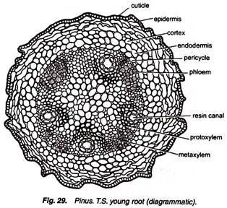
T.S. Long Shoot (Young):
1. Many leaf bases are present on the stem, due to which it appears wavy in outline.
2. Outermost single-layered, thick-walled epidermis is heavily cuticularized and followed by multilayered cortex.
3. A few outer layers of cortex are sclerenchymatous, and some inner layers are parenchymatous.
4. In the inner layers of cortex are present many resin canals.
5. The stele is eustelic or polyfascicular endarch siphonostele.
6. Vascular bundles are conjoint, collateral, open and endarch, and resemble greatly with that of a dicot stem. 5-10 vascular bundles are arranged in a ring.
7. Endodermis and pericycle are indistinguishable.
8. Narrow xylem rays connect the cortex and pith.
9. Endarch xylem consists of only tracheids.
10. Phloem is present on the ventral side and consists of sieve cells, sieve plates, phloem parenchyma and some albuminous cells.
11. Intrafascicular cambium is present in between the xylem and phloem.
12. Many leaf traces are also present.
13. A small parenchymatous pith is present in the centre of stem.
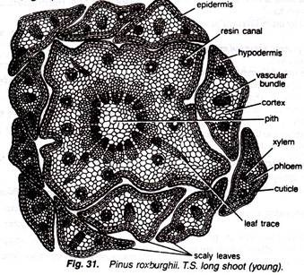
T.S. Needle (Foliage Leaf):
1. It is circular in outline in Pinus monophylla, semicircular in P. sylvestris and triangular in P. longifolia, P. roxburghii, etc.
2. Outermost layer is epidermis, which consists of thick-walled cells. It is covered by a very strong cuticle.
3. Many sunken stomata are present on the epidermis.
4. Each stoma opens internally into a substomatal cavity and externally into a respiratory cavity or vestibule.
5. Below the epidermis are present a few layers of thick-walled sclerenchymatous hypodermis. It is well-developed at ridges.
6. In between the hypodermis and endodermis is present the mesophyll tissue.
7. Cells of the mesophyll are polygonal and filled with chloroplasts. Many peg-like infoldings of cellulose also arise from the inner side of the wall of mesophyll cells.
8. Few resin canals are present in the mesophyll, adjoining the hypodermis. Their number is vari­able but generally they are two in number.
9. Endodermis is single-layered with barrel-shaped cells and clear casparian strips.
10. Pericycle is multilayered and consists of mainly parenchymatous cells and some sclerenchymatous cells forming T-shaped girder, which separates two vascular bundles. Transfusion tissue consists of tracheidial cells.
11. Two conjoint and collateral vascular bundles are present in the centre. These are closed but cam­bium may also present in the sections passing through the base of the needle.
12. Xylem lies towards the angular side and the phloem towards the convex side of the needle.
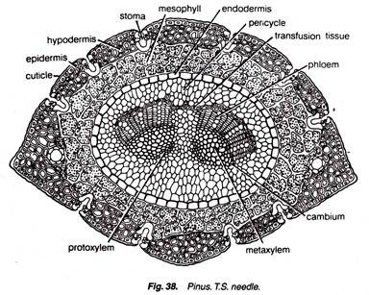
Reproductive Structures of Pinus:
1. Plant body is sporophytic.
2. Pinus is monoecious, and male and female flowers are present in the form of cones or strobili on the separate branches of the same plant.
3. Many male cones are present together in the form of clusters, each of which consists of many microsporophylls. The female cones consist of megasporophylls.
4. The male cones on the plant develop much earlier than the female cones.
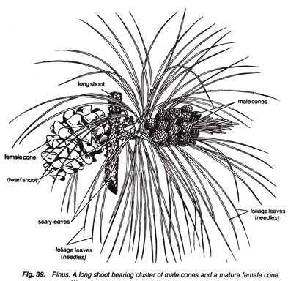

Male Cone:
1. The male cones develop in clusters in the axil of scaly leaves on long shoot.
2. They replace the dwarf shoots of the long shoot.
3. Each male cone is ovoid in shape and ranges from 1.5 to 2.5 cm. in length.
4. A male cone consists of a large number of microsporophylls arranged spirally on the cone axis.
5. Each microsporophyll is small, membranous, brown-coloured structure.
6. A microsporophyll is comparable with the stamen of the flower of angiosperms because it consists of a stalk (=filament) with a terminal leafy expansion (= anther), the tip of which is projected upwards and called apophysis.
7. Two pouch-like microsporangia (= pollen sacs) are present on the abaxial or undersurface of each microsporophyll. In each microsporangium are present many microspores (= pollen grains).
8. Each microspore or pollen grain is a rounded and yellow-coloured, light, uninucleate structure with two outer coverings, i.e., thick outer exine and thin inner intine.
9. The exine protrudes out on two sides in the form of two balloon-shaped wings. Wings help in floating and dispersal of pollen grains.
10. Wings help in floating and dispersal of pollen grains.
11. A few microsporophylls of lower side of cone are sterile. Sporangia are also not present on the adaxial surface of each microsporophyll of the male cone.
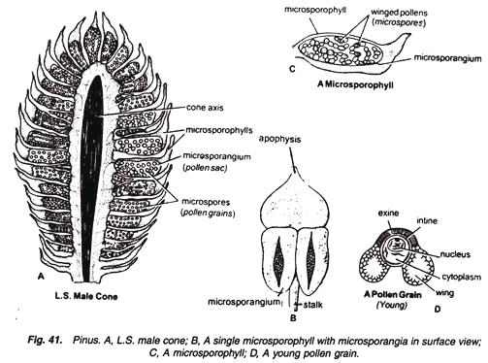
Female cone:
1. Female cone develops either solitary or in groups of 2 to 4.
2. They also develop in the axil of scaly leaves on long shoots like male cones.
3. Each female cone is an ovoid, structure when young but becomes elongated or cylindrical at maturity.
L.S. Female Cone:
1. In the centre is present a cone axis.
2. Many megasporophylls are arranged spirally on the cone axis.
3. A few megasporophylls, present at the base and at the apex of strobilus, are sterile.
4. Megasporophylls present in the middle of the strobilus are very large and they decrease in size to­wards the base and apex.
5. Each megasporophyll consists of two types of scales, known as bract scales and ovuliferous scales.
6. Bract scales are thin, dry, membranous, brown- coloured structures having fringed upper part. These are also called carpellary scales.
7. An ovuliferous scale is present on the upper surface of each bract scale.
8. Each oruliferous scale is woody, bigger and stouter than bract scale and it is triangular in shape. A broad sterile structure, with pointed tip, is present at the apex of these scales. This is called apophysis.
9. At the base of upper surface of each ovuliferous scale are present two sessile and naked ovules.
10. Micropyle of each ovule faces towards the cone axis.
11. Each ovule is orthotropous, and it remains surrounded by a single integument, consisting of an outer fleshy, a middle stony and an inner fleshy layer. It opens with a mouth opening called micro­pyle.
12. Integument surrounds the megasporangium or nucellus.
13. Just opposite the micropyle is present a pollen chamber.
14. In the endosperm or female gametophyte are present 2 to 5 archegonia.
