SOIL PROFILE

The soil profile is an important tool in nutrient management. By examining a soil profile, we can gain valuable insight into soil fertility. As the soil weathers and/or organic matter decomposes, the profile of the soil changes. For instance, a highly weathered, infertile soil usually contains a light-colored layer in the subsurface soil from which nutrients have leached away. On the other hand, a highly fertile soil often has a deep surface layer that contains high amounts of organic matter. With clues provided by soil profile, we can begin to predict how a soil will perform under certain nutrient management conditions.
Since the rise of agriculture and forestry in the 8th millennium BCE, there has also arisen by necessity a practical awareness of soils and their management. In the 18th and 19th centuries the Industrial Revolution brought increasing pressure on soil to produce raw materials demanded by commerce, while the development of quantitative science offered new opportunities for improved soil management. The study of soil as a separate scientific discipline began about the same time with systematic investigations of substances that enhance plant growth. This initial inquiry has expanded to an understanding of soils as complex, dynamic, biogeochemical systems that are vital to the life cycles of terrestrial vegetation and soil-inhabiting organisms—and by extension to the human race as well.
Soils differ widely in their properties because of geologic and climatic variation over distance and time. Even a simple property, such as the soil thickness, can range from a few centimetres to many metres, depending on the intensity and duration of weathering, episodes of soil deposition and erosion, and the patterns of landscape evolution. Nevertheless, in spite of this variability, soils have a unique structural characteristic that distinguishes them from mere earth materials and serves as a basis for their classification: a vertical sequence of layers produced by the combined actions of percolating waters and living organisms.
These layers are called horizons, and the full vertical sequence of horizons constitutes the soil profile (see the figure). Soil horizons are defined by features that reflect soil-forming processes. For instance, the uppermost soil layer (not including surface litter) is termed the A horizon. This is a weathered layer that contains an accumulation of humus (decomposed, dark-coloured, carbon-rich matter) and microbial biomass that is mixed with small-grained minerals to form aggregate structures.
Below A lies the B horizon. In mature soils this layer is characterized by an accumulation of clay (small particles less than 0.002 mm [0.00008 inch] in diameter) that has either been deposited out of percolating waters or precipitated by chemical processes involving dissolved products of weathering. Clay endows B horizons with an array of diverse structural features (blocks, columns, and prisms) formed from small clay particles that can be linked together in various configurations as the horizon evolves.
Below the A and B horizons is the C horizon, a zone of little or no humus accumulation or soil structure development. The C horizon often is composed of unconsolidated parent material from which the A and B horizons have formed. It lacks the characteristic features of the A and B horizons and may be either relatively unweathered or deeply weathered. At some depth below the A, B, and C horizons lies consolidated rock, which makes up the R horizon.
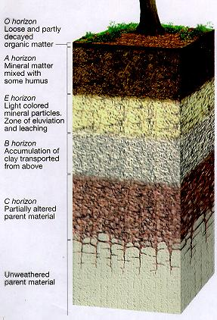

These simple letter designations are supplemented in two ways. First, two additional horizons are defined. Litter and decomposed organic matter (for example, plant and animal remains) that typically lie exposed on the land surface above the A horizon are given the designation O horizon, whereas the layer immediately below an A horizon that has been extensively leached, that is, slowly washed of certain contents by the action of percolating water is given the separate designation E horizon, or zone of eluviation. The development of E horizons is favoured by high rainfall and sandy parent material, two factors that help to ensure extensive water percolation. The solid particles lost through leaching are deposited in the B horizon, which then can be regarded as a zone of illuviation.
Soil horizon letter designations
Base symbols for surface horizons
O .... organic horizon containing litter and decomposed organic matter
A ..... mineral horizon darkened by humus accumulation
Base symbols for subsurface horizons
E ..... mineral horizon lighter in colour than an A or O horizon and depleted in clay minerals
AB or EB ..... transitional horizon more like A or E than B
BA or BE ...... transitional horizon more like B than A or E
B ...... accumulated clay and humus below the A or E horizon
BC or CB ...... transitional horizon from B to C
C ...... unconsolidated earth material below the A or B horizon
R ..... consolidated rock or rock bed.

