Protein Synthesis
The process of protein synthesis actually consists of three processes — amino acid synthesis, transcription and translation. In eukaryotic cells, transcription takes place in the nucleus. During transcription, DNA is used as a template to make a molecule of messenger RNA (mRNA). The molecule of mRNA then leaves the nucleus and goes to a ribosome in the cytoplasm, where translation occurs. During translation, the genetic code in mRNA is read and used to make a protein. These two processes are summed up by the central dogma of molecular biology:
DNA → RNA → Protein.

Transcription
Transcription is the first part of the central dogma of molecular biology: DNA → RNA. It is the transfer of genetic instructions in DNA to mRNA. During transcription, a strand of mRNA is made to complement a strand of DNA.
Steps of Transcription
Transcription takes place in three steps: initiation, elongation, and termination. The steps are illustrated in the figure below.
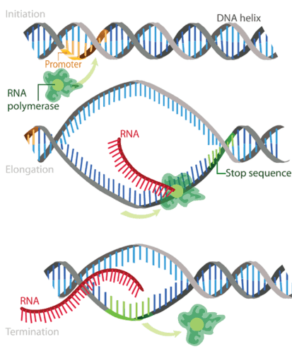
- Initiation is the beginning of transcription. It occurs when the enzyme RNA polymerase binds to a region of a gene called the promoter. This signals the DNA to unwind so the enzyme can “read” the bases in one of the DNA strands. The enzyme is ready to make a strand of mRNA with a complementary sequence of bases.
- Elongation is the addition of nucleotides to the mRNA strand.
- Termination is the ending of transcription. The mRNA strand is complete, and it detaches from DNA.

Processing of mRNA
In eukaryotes, the new mRNA is not yet ready for translation. At this stage, it is called pre-mRNA, and it must go through more processing before it leaves the nucleus as mature mRNA. The processing may include splicing, editing, and polyadenylation. These processes modify the mRNA in various ways. Such modifications allow a single gene to be used to make more than one protein.
- Splicing removes introns from mRNA. Introns are regions that do not code for the protein. The remaining mRNA consists only of regions called exons that do code for the protein. The ribonucleoproteins are small proteins in the nucleus that contain RNA and are needed for the splicing process.
- Editing changes some of the nucleotides in mRNA. For example, a human protein called APOB, which helps transport lipids in the blood, has two different forms because of editing. One form is smaller than the other because editing adds an earlier stop signal in mRNA.
- Polyadenylation adds a “tail” to the mRNA. The tail consists of a string of As (adenine bases). It signals the end of mRNA. It is also involved in exporting mRNA from the nucleus, and it protects mRNA from enzymes that might break it down.

Translation
Translation is the second part of the central dogma of molecular biology: RNA → Protein. It is the process in which the genetic code in mRNA is read to make a protein. Translation is illustrated in the diagram below. After mRNA leaves the nucleus, it moves to a ribosome, which consists of rRNA and proteins. The ribosome reads the sequence of codons in mRNA, and molecules of tRNA bring amino acids to the ribosome in the correct sequence.
Each tRNA molecule has an anticodon for the amino acid it carries. An anticodon is complementary to the codon for an amino acid. For example, the amino acid lysine has the codon AAG, so the anticodon is UUC. Therefore, lysine would be carried by a tRNA molecule with the anticodon UUC. Wherever the codon AAG appears in mRNA, a UUC anticodon of tRNA temporarily binds. While bound to mRNA, tRNA gives up its amino acid. With the help of rRNA, bonds form between the amino acids as they are brought one by one to the ribosome, creating a polypeptide chain. The chain of amino acids keeps growing until a stop codon is reached.

Protein folding
After a polypeptide chain is synthesized, it may undergo additional processes. For example, it may assume a folded shape due to interactions between its amino acids. It may also bind with other polypeptides or with different types of molecules, such as lipids or carbohydrates. Many proteins travel to the Golgi apparatus within the cytoplasm to be modified for the specific job they will do.
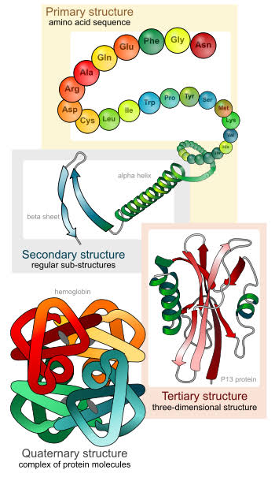
Summary
- Protein synthesis is the process in which cells make proteins. It occurs in two stages: transcription and translation.
- Transcription is the transfer of genetic instructions in DNA to mRNA in the nucleus. It includes three steps: initiation, elongation, and termination. After the mRNA is processed, it carries the instructions to a ribosome in the cytoplasm.
- Translation occurs at the ribosome, which consists of rRNA and proteins. In translation, the instructions in mRNA are read, and tRNA brings the correct sequence of amino acids to the ribosome. Then, rRNA helps bonds form between the amino acids, producing a polypeptide chain.
- After a polypeptide chain is synthesized, it may undergo additional processing to form the finished protein.
