Classification of Gymnosperms

Sporne (1965) classified gymnosperms into 3 classes, 9 orders and 31 families. The classes include i) Cycadospsida ii) Coniferopsida iii) Gnetopsida.
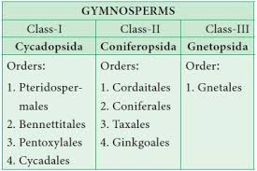

General Characters of Main classes:
Class I – Cycadopsida
• Plants are palm-like or fern-like.
• Compound, frond-like pinnate leaves.
• Manoxylic wood.
• Sperms are motile.
• Flower like structures are absent. Strobili are simple.
- Most of the members of this group are extinct.
Example: Cycas, Zamia.

Class II – Coniferopsida
• Tall trees with simple leaves of varied shape. Form the luxurious dense coniferous forest in temperate regions.
• Wood is pycnoxylic.
• Cone like strobili are present.
• Motile sperms are absent (except Ginkgo biloba).
Example: Pinus, Podocarpus, Tsuga

Class III – Gnetopsida
• Shrubs, trees and lianas.
• Leaves are elliptical or strap-shaped, simple, opposite or whorled.
• Motile sperms are absent.
• Wood contains vessels.
• Strobili is called as inflorescence.
• Flower like structure with perianth is present. Almost similar to angiosperms except for naked ovules.
Example: Gnetum, Ephedra.

