LICHENS: CHARACTERISTICS AND CLASSFICATION

Lichens are a small group of plants of composite nature, consisting of two dissimilar organisms, an alga-phycobiont (phycos-alga; bios-life) and a fungus-mycobiont (mykes-fungus; bios-life); living in a symbiotic association.
Generally the fungal partner occupies the major portion of the thallus and produces its own reproductive structures. The algal partner manufactures the food through photosynthesis which probably diffuses out and is absorbed by the fungal partner.

Characteristics of Lichens:
1. Lichens are a group of plants of composite thalloid nature, formed by the association of algae and fungi.
2. The algal partner-produced carbohydrate through photosynthesis is utilised by both of them and the fungal partner serves the function of absorption and retention of water.
3. Based on the morphological structure of thalli, they are of three types crustose, foliose and fruticose.
4. Lichen reproduces by all the three means – vegetative, asexual, and sexual.
(a) Vegetative reproduction: It takes place by fragmentation, decaying of older parts, by soredia and isidia.
(b) Asexual reproduction: By the formation of oidia.
(c) Sexual reproduction: By the formation of ascospores or basidiospores. Only fungal component is involved in sexual reproduction.
5. Ascospores are produced in Ascolichen.
(a) The male sex organ is flask-shaped spermogonium, produces unicellular spermatia.
(b) The female sex organ is carpogonium (ascogonium), differentiates into basal coiled oogonium and elongated trichogyne.
(c) The fruit body may be apothecia! (discshaped) or perithecial (flask-shaped) type.
(d) Asci develop inside the fruit body containing 8 ascospores. After liberating from the fruit body, the ascospores germinate and, in contact with suitable algae, they form new lichen.
6. Basidiospores are produced in Basidiolichen, generally look like bracket fungi and basidiospores are produced towards the lower side of the fruit body.
7. The growth of lichen is very slow, they can survive in adverse conditions with high temperature and dry condition.

Habit and Habitat of Lichens:
There is about 400 genera and 15,000 species of lichens, widely found in different regions of the world.
The plant body is thalloid; generally grows on bark of trees, leaves, dead logs, bare rocks etc., in different habitat.
They grow luxuriantly in the forest areas with free or less pollution and with abundant moisture.
Some species like Cladonia rangiferina (reindeer moss) grows in the extremely cold condition of Arctic tundras and Antarctic regions.
In India, they grow abundantly in Eastern Himalayan regions.
They do not grow in the highly polluted regions like Industrial areas.
The growth of lichen is very slow.

Depending on the growing region, the lichens are grouped as:

1. Corticoles: Growing on bark of trees, mainly in the sub-tropical and tropical regions.

2. Saxicoles: Growing on rocks, in cold climate.

3. Terricoles: Growing on soil, in hot climate, with sufficient rain and dry summer.

Associated Members of Lichens:
The composite plant body of lichen consists of algal and fungal members.
The algal members belong to Chlorophyceae (Trebouxia, Trentepohlia, Coccomyxa etc.), Xanthophyceae (Heterococcus) and also Cyanobacteria (Nostoc, Scytonema etc.) (Fig. 4.111).

The fungal members mainly belong to Ascomycotina and a few to Basidiomycotina. Among the members of Ascomycotina, Discomycetes are very common; producing huge apothecia, others belong to Pyrenomycetes or Loculoascomycetes.
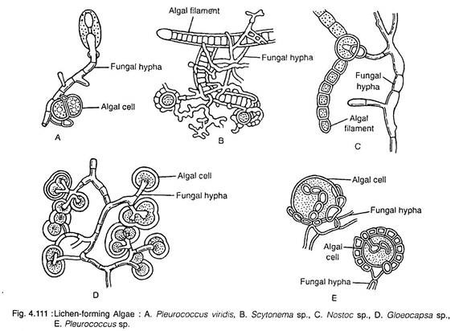

The members of Basidiomycotina belong to Thelephoraceae.

Nature of Association of Lichens:

There are three views regarding the nature of association of algal and fungal partners in lichen:

1. According to some workers, the fungus lives parasitically, either partially or wholly, with the algal components.
This view gets support for the following evidences:
(i) Presence of haustoria of fungus in algal cells of some lichen.
(ii) On separation, the alga of lichen is able to live independently, but the fungus cannot survive.

2. According to others, they live symbiotically, where both the partners are equally benefitted. The fungal member absorbs water and mineral from atmosphere and substratum, make available to the alga and also protects algal cells from adverse conditions like temperature etc. The algal member synthesises organic food sufficient for both of them.

3. According to another view, though the relationship is symbiotic, the fungus shows predominance over the algal partner, which simply lives as subordinate partner. It is like a master and slave relationship, termed helotism.

